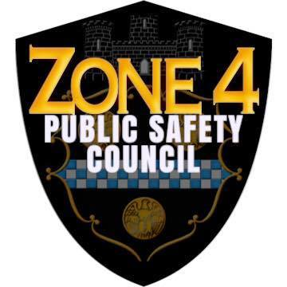
.ZONE 4
PUBLIC SAFETY COUNCIL

Greenfield

Glen Hazel

Hazelwood

Hays

Lincoln Place

New Homestead

Oakland

Park Place

Point Breeze

Regent Square

Shadyside

Squirrel Hill

Swisshelm Park

AGENDA

Zone 4 Public Safety Council
6:30 PM Thursday, May 19, 2022
On Site Meeting

Jewish Community Center
5738 Forbes Avenue, Room 318
Pittsburgh PA 15217

- Welcome / Introductions
- Zone 4 Police: Reports, Announcements, Questions
  - Commander Griffin and Community Resource Officers
- Department of Public Safety Announcements - John Tokarski
- Miscellaneous Updates
  - University of Pittsburgh Police
  - CeaseFirePA - Josh Fleitman
- Special Presentation:
  - Restorative Safe Passages,
    - Infinite Life Solutions - Cecelia Ware, Executive Director
- Future Meetings
  - Email suggested topics and speakers to pghzone4publicsafetycouncil@gmail.com

